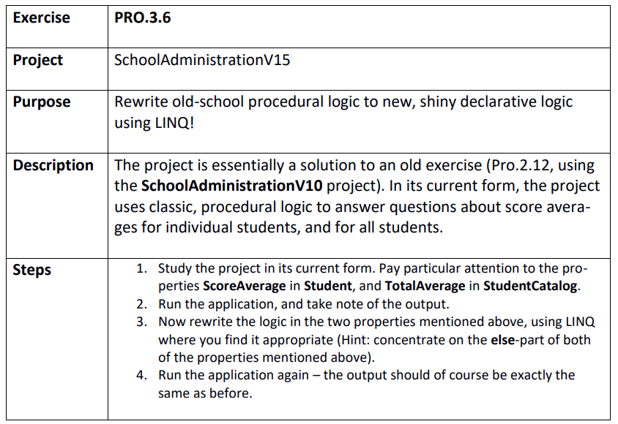

Step 1 & 2
C:\Git\OOProg25\Chap\Prog03\MySolution\PRO.3.6 - SchoolAdministrationV15\SchoolAdministrationV15\SchoolAdministrationV15.sln

Step 3
